A Project Report On

File Defender

Submitted in partial fulfillment of the requirement for the award of the degree

MASTER OF SCIENCE IN
CYBER SECURITY AND CYBER LAW
M.Sc. (CS & CL)

Academic Year 2023 – 24

Henry Ndolleh Alpha (92100565013)
Boukary Kabore (92100565015)

Internal Guide
Prof. Rashmin J. Dave


Rajkot-Morbi Road, At & PO : Gauridad, Rajkot 360 003. Gujarat. India.

Faculty of Computer Applications (FCA)



This is to certify that the project work entitled

File Defender

submitted in partial fulfillment of the requirement for

the award of the degree of

MASTER OF SCIENCE IN

CYBER SECURITY AND CYBER LAW

M.Sc. (CS & CL)

of the

Marwadi University

is a result of the bonafide work carried out by

Henry Ndolleh Alpha - (92100565013)

Boukary Kabore – (92100565015)

during the academic year 2023-24

Prof. Rashmin J. Dave Dr. Ashwin Dobariya Dr. R. Sridaran
Faculty Guide |  | HOD |  | Dean

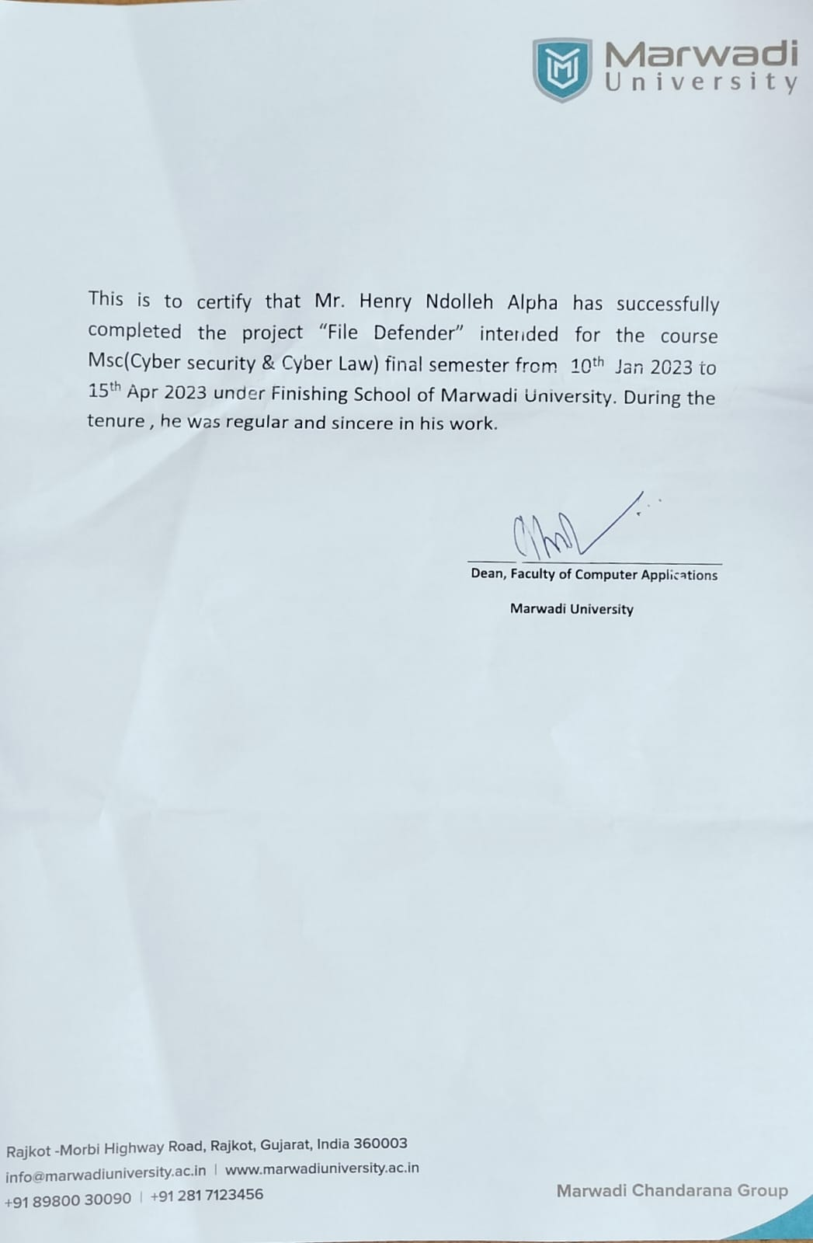
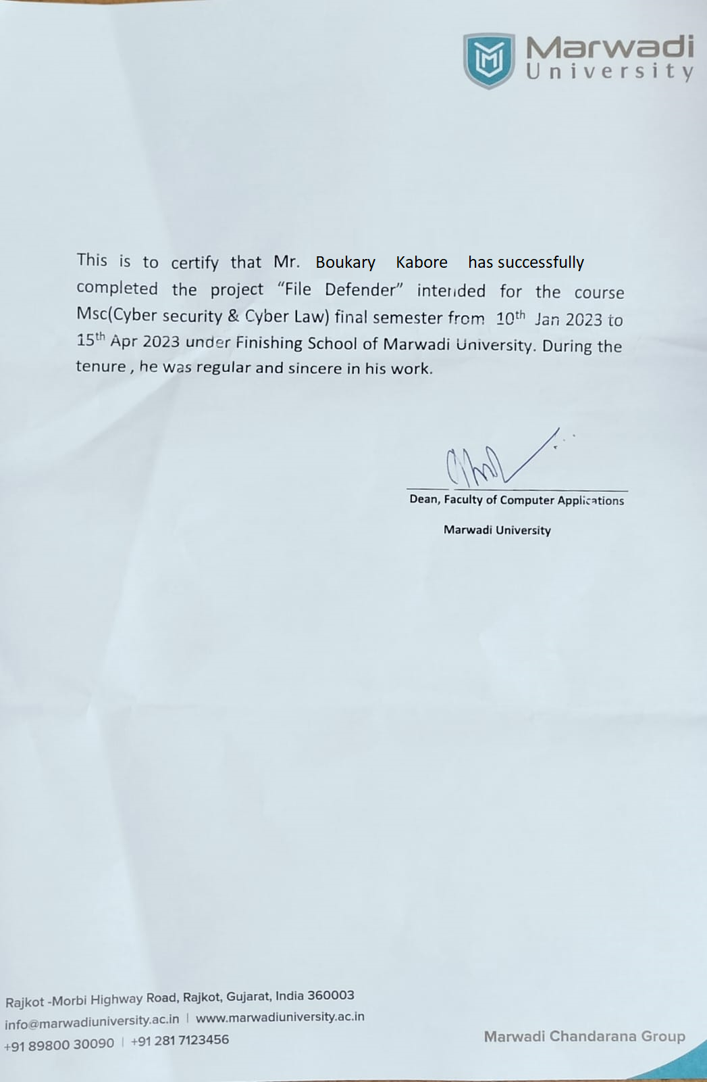
DECLARATION

We hereby declare that this project work entitled File Defender is a record done by us.

We also declare that the matter embodied in this project is genuine work done by us and has not been submitted whether to this University or to any other University / Institute for the fulfillment of any course of study.

Place: Rajkot, Gujarat, India
Date: __________________

Henry Ndolleh Alpha (92100565013) Signature:
Boukary Kabore (92100565015) Signature:

ACKNOWLEDGEMENT

We would like to express my sincere gratitude to everyone who has supported and helped us throughout this project. First and foremost, we would like to thank Almighty Allah for giving us the strength and ability to complete this project.

We would like to extend our heartfelt appreciation to our parents, who have been our inspiration and motivation. Despite their struggles, they has always been our rock and supported us through thick and thin. There unconditional love and support have been instrumental in our success.

We are very thankful to our faculty guide Prof. Rashmin J. Dave, the person who makes us follow the right steps during project work. We express our deep sense of gratitude to his guidance, suggestions and expertise at every stage. Apart from that his valuable and expertise suggestion during documentation of our report indeed helped us a lot.

We would also like to thank our family and friends for their unwavering support and encouragement. Their support and encouragement have been invaluable to us, and we could not have done this without them.

We are heartily thankful to our external guide Prof. Divyesh Bamrotiya .U for providing us an opportunity to work over this report and for his endless and great support. We’re also thankful to our Head Dr. Ashwin Dobariya and Dean Dr. R. Sridaran for their support as and when required. We would like to extend our gratitude towards all who directly or indirectly supported and helped us to accomplish this project work.

Henry Ndolleh Alpha (92100565013) Signature:
Boukary Kabore (92100565011) Signature:
COMPANY PROFILE

Company Name: TechdefenceLabs
TechdefenceLabs is a leading company in the field of ethical hacking, information security and cyber forensics. We offer training courses and workshops for individuals and organizations who want to learn and enhance their skills in these domains. Our vision is to create a secure and ethical digital world by empowering our clients with the knowledge and tools to protect themselves from cyber threats.

We have a team of highly qualified and experienced trainers who have received various awards and recognition for their expertise and achievements in the industry. Our CEO, Mr. Sunny Vaghela, is the Indian Ambassador of Cyber Security for the year 2018. He has been instrumental in solving many high-profile cyber-crimes and creating awareness among the masses.

We have a global presence and reach, having trained more than 85,000 individuals from different sectors and backgrounds. We have partnered with several prestigious institutions and organizations such as IITs, ISACA, Yahoo, Google, ZOHO etc. to deliver our courses and workshops. We have also collaborated with government agencies such as Crime Branches and Cyber Crime Cells to provide training on cyber law enforcement.

We are the pioneers of Hack Track- India's first IT Security Opportunities portal that connects aspiring hackers with potential employers. We have more than 7000 members registered on our portal who can access various resources and opportunities related to cyber security.

We are committed to providing quality education and services to our clients at affordable prices. We constantly update our curriculum and methodology to keep pace with the latest trends and technologies in the field. We also provide online support and guidance to our students after completion of their courses.
CONTENTS

Chapters | Particulars | Page No.
1 | SYNOPSIS | 1
2  2.1  2.2  2.3  2.4  2.5  2.6  2.7  2.8  2.9  2.10 | PREAMBLE  General Introduction  Statement of Problem  Objective of the Study  Module Description with functionality  Graphical User Interface  Encryption and Decryption  Malware Scanning  Scope of the Study  Methodology  Feasibility Study | 2  2  3  3  4  4  5  5  5  6  6
3  3.1  3.2  3.3  3.4  3.5 | REVIEW OF LITERATURE  Introduction  Existing Methods and Techniques  Manual Methods  Security threats and challenges  Solutions | 7  7  7  8  8  9
4  4.1  4.2  4.3 | TECHNICAL DESCRIPTION  Software Requirement  Hardware Requirement  Libraries used and their Descriptions | 11  11  11  11
5  5.1  5.2 | SYSTEM DESIGN AND DEVELOPMENT  Architectural Design / System Flow  Redistribution | 13  13  14
6  6.1  6.2  6.3  6.4  6.5  6.6 | SYSTEM DEVELOPMENT AND TESTING  Environment Setup  Python Installation  Virtual Environment Setup  Code Editor Installation  Packages Installation  Distribution and Testing | 17  17  17  17  17  17  17
7 | CONCLUSION | 24
8 | LEARNING DURING PROJECT WORK | 25
9 | FUTURE ENHANCEMENTS | 26
10  10.1 | BIBLIOGRAPHY  Online References | 27  27

FIGURE INDEX

Sr. No. | Figure No. | Particulars | Page No.
1 | Figure 1 | Functions Data Flow Diagram | 15
2 | Figure 2 | Process Flowchart Diagram | 16
3 | Figure 3 | Main code | 18
4 | Figure 4 | Encryption code | 18
5 | Figure 5 | Decryption code | 19
6 | Figure 6 | Malware Scanning code | 19
7 | Figure 7 | Files created | 20
8 | Figure 8 | GUI of the program | 20
9 | Figure 9 | Result of the program encrypted directory | 21
10 | Figure 10 | Result of the program decrypted directory | 21
11 | Figure 11 | Result of the program malware scanning a directory | 22
12 | Figure 12 | Single file with malware | 22
13 | Figure13 | Single file with no malware | 23

TABLE INDEX

Sr. No. | Table No. | Particulars | Page No.
1 | Table 1 | Software requirements | 12
2 | Table 2 | Hardware requirements | 12

Chapter 1

SYNOPSIS
File Defender is a python program that provides an easy-to-use graphical user interface for encrypting and decrypting files or directory, as well as scanning them for malware. Its objective is to enhance the security of users' sensitive files by preventing unauthorized access and protecting against malware infections.
The program consists of several modules with different functionalities, including a file encryption module that uses the AES-256 encryption algorithm to secure files with a password, and a decryption module that allows authorized users to unlock and access the encrypted files. Additionally, there is a malware scanning module that checks files for known virus signatures and alerts users if any malware is detected.
The program is designed to be user-friendly and requires minimal technical expertise. It can be easily installed on a Windows machine and runs on a Python environment with the necessary packages installed. The program's functionality is further enhanced by the use of external libraries such as cryptography and virus total API, which help to perform complex operations with ease.
The development and testing of the program followed a structured methodology, including a feasibility study, literature review, and technical design. The software's architecture and system flow were carefully planned to ensure optimal performance and efficiency, and the program underwent rigorous testing to ensure its stability and reliability.
Overall, File Defender is a powerful and user-friendly tool that helps users to protect their sensitive files from unauthorized access and malware infections. Its versatility and ease of use make it an excellent choice for individuals and organizations looking to enhance their file security.

Chapter 2

Preamble
This document presents the final thesis project paper for the development of "File Defender," a software application designed to provide advanced security features for file encryption, decryption, and malware scanning. The project was carried out to address the growing concerns of file security and data protection in the digital world.
The development of this software aimed to provide a solution to protect sensitive data stored on digital devices. The program's functionality includes a Graphical User Interface (GUI) for easy navigation, an advanced encryption and decryption algorithm for secure data storage, and a malware scanning feature to detect and remove any potential security threats.
This paper includes a detailed description of the software's design, development, and testing. Additionally, a review of literature related to the project's scope is provided to highlight the existing methods and techniques in file security and data protection.
The paper concludes with a discussion of the project's outcomes, highlighting the lessons learned during the development process and recommendations for future enhancements.

2.1. General Introduction
The use of computers has become an essential aspect of daily life, and the internet has made it easier to access information and services globally. However, with this convenience comes a significant risk to personal and organizational data security. Cybersecurity has become a critical issue in recent years, with cyber-attacks increasing in frequency, sophistication, and impact. As such, protecting data from unauthorized access and malicious attacks has become a top priority for individuals and organizations alike.
File Defender is a tool designed to provide users with a simple yet powerful solution for securing their files against various security threats. The software integrates multiple features, including encryption and decryption, malware scanning, and a user-friendly graphical user interface (GUI). The software is aimed at providing a secure environment for users to store and transfer sensitive data while minimizing the risk of data breaches and cyber-attacks.
This project aims to develop an effective file protection software tool with a simple user interface, high functionality, and ease of use. The following sections will provide a detailed description of the project, including the problem statement, objectives, methodology, and technical aspects of the software development process.

Statement of Problem
In today's digital age, data security is a major concern. With the increasing use of computers and the internet, it has become easier for malicious actors to gain unauthorized access to sensitive information. One of the primary ways that cybercriminals use to gain access to personal or confidential data is by infecting a computer with malware.
Malware is malicious software designed to harm, disrupt, or take control of a computer system without the owner's knowledge or consent. Malware can be in the form of viruses, worms, Trojan horses, spyware, adware, ransomware, and many others. Once a computer is infected with malware, it can be used to steal sensitive information, damage or delete data, and cause other forms of harm.
The use of encryption can help protect sensitive data from unauthorized access, but it requires a high level of technical expertise to implement. Additionally, many people are not aware of the dangers of malware and do not have adequate protection in place. There is a need for a user-friendly and accessible program that can provide both encryption and malware scanning capabilities to help users secure their data.
This project aims to address the above challenges by developing a program called File Defender, which provides users with a simple and easy-to-use interface to encrypt their files and scan for malware. The program will be designed to be user-friendly and accessible to users with minimal technical knowledge, while also providing robust security features to protect their data.

Objective of the Study
The main objective of this study is to develop a file security tool that can protect users' data from malware attacks and unauthorized access. The tool will provide an easy-to-use graphical interface for users to encrypt and decrypt their files, as well as scan for malware. The program will also have the ability to detect and remove malware from the user's system. Additionally, the study aims to investigate the effectiveness of the tool in terms of its security capabilities and usability for non-technical users. Overall, the objective of the study is to provide a secure and reliable file protection tool for users.

Module Description with functionality
The File Defender program is divided into several modules, each of which performs a specific function. Here is a brief description of each module and its functionality:
- Encryption Module - This module encrypts user-selected files and folders using AES-256 encryption. The encryption key is generated using a user-defined password.
- Decryption Module - This module decrypts previously encrypted files and folders. The user must provide the correct password used during encryption to successfully decrypt the files.
- Malware Scanning Module - This module scans a single file and a directory the user-selected files or directory for malware scanner to uses signature-based detection and heuristic analysis techniques to identify malware in files.
- Graphical User Interface (GUI) Module – This module provides a user-friendly interface for interacting with the program. It allows the user to select files and folders for encryption or decryption, initiate a file or directory malware scanning, clear output clear button and scroll up and scroll down button.

Graphical User Interface
The Graphical User Interface (GUI) of the File Defender program is designed to be user-friendly and intuitive. It allows the user to easily navigate through the different functions of the program and perform various tasks with ease.
The GUI consists of a main window with several tabs, each corresponding to a specific function of the program. The tabs are as follows:
- Home: This tab provides a quick welcome and overview of the program and its main features.
- Encryption: This tab allows the user to encrypt files using AES-256 encryption. The user can select one or multiple files to encrypt.
- Decryption: This tab allows the user to decrypt files that have been encrypted with the program. The user can select one or multiple files to decrypt, through the encrypted key that was generated used to encrypt the files, and specify the output directory.
- Malware Scan: This tab allows the user to scan a file or a specific directory for malware using the signatures. The user can choose to scan specific files or directories, and view the scan results.
- Clear Button: This tab allows the user to clears the output from the widget.
The GUI also includes a scroll up and scrolls down at right hand side of the widget to help quick scrolling of the user output in the widget. Overall, the GUI provides a simple and efficient way for users to protect their files and scan their computer for malware.

Encryption and Decryption
The File Defender program provides the user with an encryption and decryption feature. Encryption is the process of converting a plain text file into a cipher text file that cannot be easily understood by unauthorized users. Decryption is the process of converting the cipher text back into plain text using a decryption key. The encryption algorithm used in the File Defender program is the Advanced Encryption Standard (AES) algorithm, which is a widely used and highly secure encryption standard. The program allows the user to encrypt and decrypt any file by providing a key that serves as the encryption/decryption key.

Malware Scanning
The File Defender program includes a malware scanning module that allows users to scan files for potential threats. The malware scanner uses signature-based detection and heuristic analysis techniques to identify malware in files. The program provides options for users to scan individual files or entire directories. When a potential threat is detected, the user is notified and given options for further action, such as quarantining or deleting the infected file. The malware scanning module is designed to be fast and efficient, while also providing a high level of accuracy in identifying threats.

Scope of the Study
The scope of this study is a Python-based program which focused on the following:
- Functionality: The program is designed to protect files from unauthorized access and modification by using encryption and decryption techniques as well as scanning for any malicious threats. The scope of the study includes examining the functionality of the program in terms of how effectively it performs these tasks.
- User Interface: The user interface of the program is a critical aspect that determines the ease of use and user-friendliness of the program. The scope of the study includes examining the user interface of the program and evaluating how well it facilitates user interaction.
- Performance: The performance of the program is a critical aspect that determines its effectiveness and efficiency in handling large files and processing them quickly. The scope of the study includes evaluating the performance of the program in terms of its speed and efficiency.
- Security: The security of the program is a crucial aspect that determines how well it can protect files from unauthorized access and modification. The scope of the study includes examining the security features of the program and evaluating how well they can protect files.
- Compatibility: The program's compatibility with different operating systems, file types, and hardware configurations is an essential aspect that determines its usability. The scope of the study includes examining the compatibility of the program with windows operating systems, file types, and hardware configurations.
The above aspects form the scope of the study for the File Defender program, and a thorough evaluation of these aspects will determine the effectiveness and usability of the program.

Methodology
The project methodology base on using Python programming language to develop a program that can encrypt, decrypt and scan for malware. The program will use libraries and modules such as tkinter, os, hashlib, yara, json, signatures and cryptography, which will collect and analyze files information to determine the security of threat. The program is designed to be user-friendly and easy-to-use, with a graphical user interface (GUI) for easy interaction with the user. The program will also implement advance encryption algorithms and scanning of the file or directory to ensure data safety.

Feasibility Study
Analysis of the technical, financial, and operational issues of creating the programmed is part of the project's feasibility study. The project's technical viability is assessed by looking at the availability of the tools, resources, and technical know-how needed to create the programmed. Analyzing the program's development costs, which include those for labour, hardware, and software, allows for the determination of its economic viability. By examining the program's usability and user acceptance, the operational viability is established. The feasibility analysis demonstrates that the project is operationally, economically, and technically feasible.

Chapter 3

3. Literature Review

3.1. Introduction
Data security is a vital component of cybersecurity, and preventing data breaches from cyber criminal is a critical aspect. Therefore, we have created this tool to assist users in protecting their data from threat. These resources may be a vital part of the arsenal of an information security analyst. The methods and techniques currently used for encrypting, decrypting, and scanning for malware in files or directories using Python or other programming languages will be examined in this review of the literature, as well as the security risks and difficulties these programmers pose to users' privacy and data protection, as well as potential countermeasures and solutions that can stop access to users' sensitive information.

Existing Methods and Techniques
There are several existing methods and techniques in the field of cybersecurity that are relevant to the functionality provided by File Defender. These include:
- Encryption: This technique is used to protect data by converting it into a coded language that can only be read by those who have the decryption key. This is a common method used to prevent unauthorized access to sensitive data.
- Decryption: This technique is used to convert encrypted data back into its original form using a decryption key. This is essential to be able to read or use the data that has been encrypted.
- Malware Scanning: This is the process of detecting and removing malware (malicious software) from a system or file. This technique is used to identify and remove viruses, Trojans, spyware, and other harmful software that can damage or steal data.
- Digital Signatures: This is a cryptographic technique used to verify the authenticity and integrity of digital documents or messages. A digital signature is a code that is attached to a document or message that verifies that it was created by the sender and that it has not been altered since it was created.
- Hashing: This technique is used to generate a unique code (a hash) for a piece of data that can be used to verify its integrity. This is often used in combination with digital signatures to ensure that data has not been altered.
- Symmetric Encryption: This is a type of encryption that uses a single key for both encryption and decryption. This technique is often used to encrypt data that is stored on a device.
- Asymmetric Encryption: This is a type of encryption that uses two keys - one for encryption and one for decryption. This technique is often used for secure communication over a network.
- Virus Definitions: This is a database of known viruses and malware that is used by antivirus software to detect and remove malicious code.
- Signature-based Detection: This is a method of malware detection that looks for specific patterns or signatures in code that are associated with known malware.
- Heuristic Analysis: This is a method of malware detection that looks for suspicious behavior or patterns in code that may indicate the presence of malware.

Manual Methods
Manual methods refer to the use of human effort to perform tasks in a system. In the context of cybersecurity, manual methods are often employed to detect and respond to security threats. These methods involve the use of expert knowledge and intuition to identify security risks and vulnerabilities. Some examples of manual methods in cybersecurity include:
- Penetration testing: Penetration testing is a manual method of evaluating the security of a system. It involves simulating an attack on a system to identify potential vulnerabilities and weaknesses that an attacker could exploit.
- Vulnerability scanning: Vulnerability scanning involves manually scanning a system for known vulnerabilities. This can be done using commercial vulnerability scanning tools or manually by an expert.
- Security audits: Security audits involve manually reviewing the security controls and processes in a system to identify potential security gaps and weaknesses.
- Incident response: Incident response involves the manual investigation and remediation of security incidents. This can involve isolating affected systems, analyzing logs and network traffic, and identifying and removing malware.
- Security awareness training: Security awareness training is a manual method of educating employees about security risks and best practices. This can include training on password hygiene, phishing attacks, and other security topics.

Security Threats and Challenges
While the File Defender program offers several useful features, there are several security threats and challenges associated with its implementation. Here are a few potential security threats and challenges to consider:
- Encryption Keys: The program generates a new encryption key using Python's os.urandom(32) function. This key is then saved to a file on the user's system. If an attacker gains access to this key, they can easily decrypt any encrypted files. Thus, the security of the program largely depends on the security of the key file.
- Malware Scanning: The malware scanning feature of the program may be vulnerable to evasion techniques used by modern malware. Some malware is designed to evade detection by antivirus software, and the same could be true for the malware scanning algorithm implemented in this program. Additionally, if the signatures folder used for malware scanning is not kept up-to-date, new malware may be able to evade detection.
- User Input Validation: The program takes user input from file dialog boxes to encrypt, decrypt, and scan files and directories. If the program fails to validate this input properly, it may be possible for an attacker to inject malicious code or access files outside of the intended directory.
- UI Vulnerabilities: The program's user interface may be vulnerable to attacks such as clickjacking, cross-site scripting (XSS), and cross-site request forgery (CSRF). If an attacker can manipulate the program's user interface, they may be able to gain unauthorized access or perform malicious actions on the user's system.
- File Integrity: The program relies on the integrity of the files it encrypts and decrypts. If a file is corrupted or modified in some way, the program may not be able to decrypt it properly, leading to data loss or corruption.
- Key Management: The program does not provide any key management features, such as key rotation or revocation. If a key is compromised, the program provides no way to revoke that key or generate a new one. Additionally, if the user loses the encryption key, there is no way to recover the encrypted data.
- Outdated Libraries: The program imports several libraries, including tkinter, termcolor, and datetime. If these libraries are outdated or contain vulnerabilities, an attacker may be able to exploit these vulnerabilities to gain unauthorized access to the user's system.
To mitigate these potential security threats and challenges, the program should implement appropriate security controls such as secure key management, input validation, and UI hardening. Additionally, the program should be regularly updated to ensure that all libraries are up-to-date and free of known vulnerabilities.

Solutions
There are several solutions to address the security threats and challenges of the program. Some of the possible solutions are:
- Implement access controls: Implementing access controls such as authentication and authorization can ensure that only authorized personnel can access the program.
- Encrypt data: Encrypting sensitive data that is stored or transmitted by the program can protect it from unauthorized access.
- Use secure coding practices: Using secure coding practices can help prevent vulnerabilities that could be exploited by attackers.
- Implement firewalls: Implementing firewalls can help prevent unauthorized access to the program from external sources.
- Regularly update software and systems: Keeping software and systems up-to-date with the latest security patches can help prevent vulnerabilities from being exploited by attackers.
- Conduct regular security assessments: Conducting regular security assessments can help identify vulnerabilities and potential security risks and enable timely remediation.
- Train employees: Educating employees about security best practices and providing training on how to recognize and respond to security threats can help reduce the risk of human error leading to security breaches.
- Implement a disaster recovery plan: Implementing a disaster recovery plan can help ensure that in the event of a security breach or other disaster, the program can be restored quickly and with minimal disruption to operations.

Chapter 4

Technical Description

Software Requirements
Operating system | Windows
For Developers
Programming Language | Python 3
Python Modules required for installation | tkinter, os, pycrypto, hashlib, yara, argparse, crypto.cipher, datetime, os.urandom(16), termcolor, configparser, json, base64, PyCryptodome, win32crypt, locale, platform, pathlib, itertools, subprocess, typing, request, reportlab
Tools | VScode
Table 1. Hardware requirements

Hardware Requirements
RAM | Minimum 4 GB or Higher
CPU | Minimum dual-core CPU
HDD/SSD | 1GB or higher
Display | 1024*768 resolution or higher
Network Interface Card (NIC) with Wi-Fi Capability
Table 2. Hardware requirements

Libraries used and their descriptions
- tkinter: The tkinter package (“Tk interface”) is the standard Python interface to the Tcl/Tk GUI toolkit. Both Tk and tkinter are available on most Unix platforms, including macOS, as well as on Windows systems.
- os: This module provides a way of interacting with the operating system. It provides a way of using operating system dependent functionality like reading or writing to the file system.
- pyCrypto: the pyCrypto is the collection of secure hash functions and various encryption algorithms. The package is designed in such a way to make structured modules as and when required
- hashlib: the hashlib module provides a helper function for efficient hashing of a file or file-like object.
- yara: the yara rules are used to classify and identify malware samples by creating descriptions of malware families based on textual or binary patterns.
- argparse: This module provides a way to write user-friendly command-line interfaces.
- crypt.cipher: The Crypto.Cipher package contains algorithms for protecting the confidentiality of data.
- dateTime: This module supplies classes for working with dates and times. We use the datetime module to represent dates and times in Python, perform arithmetic with dates and times, and convert dates and times to various string formats.
- os.urandom(): The method is used to generate a string of size random bytes suitable for cryptographic use or we can say this method generates a string containing random characters.
- termcolor: this module is a python module for ANSII Color formatting for output in the terminal.
- configparser: This module provides a way to read and write configuration files in a standard format.
- json: This module provides a way to encode and decode data in JSON format. JSON (JavaScript Object Notation) is a lightweight data interchange format that is easy for humans to read and write and for machines to parse and generate.
- base64: This module provides functions to encode and decode data in base64 format.
- pyCryptodome: This module provides cryptographic functions and primitives including hashing, encryption, and decryption.
- platform: This module provides an interface to various services that provide information about the host platform
- pathlib: This module in Python deals with path related tasks, such as constructing new paths from names of files and from other paths, checking for various properties of paths and creating files and folders at specific paths.
- subprocess: This module provides a way to spawn new processes, connect to their input/output/error pipes, and obtain their return codes.
- subprocess: This module provides a way to spawn new processes, connect to their input/output/error pipes, and obtain their return codes.
- request: The requests module allows you to send HTTP requests using Python. The HTTP request returns a Response Object with all the response data (content, encoding, status, etc).

Chapter 5

System Design and Development

Architectural Design / System Flow
Architectural Design
The File Defender is a desktop-based application designed to provide security to user files through the following functionalities:
- Encryption of files and folders
- Decryption of encrypted files and folders
- Scanning of files and directories for malware infections
The program was implemented using the following languages and libraries:
- Python 3.8
- tkinter for GUI development
- The termcolor module for colorizing terminal output
- datetime module for generating timestamps
- os module for file-related operations
- pycrypto module for encryption and decryption
- hashlib module for hashing data
- pathlib module for file path handling
The GUI was implemented using the tkinter library, while the program's functionalities were implemented as functions that were called by the GUI's event handlers.
System Flow:
When the program is launched, the user is presented with a GUI window that contains the following elements:
- A label displaying the name of the program
- A menu bar containing options for encryption, decryption, and malware scanning
- A listbox displaying the output of the program
- A button to clear the output of the listbox
- A label that displays the report when malware scanning is completed
When the user clicks on the encryption or decryption options in the menu bar, the program prompts the user to select the file or folder to encrypt/decrypt. After selecting the file or folder, the program generates a new encryption key using the os.urandom() function, saves the key to a file, and encrypts the file or folder using the generated key. If the decryption option is selected, the program prompts the user to select the key file used for encryption and then decrypts the file or folder using the selected key file.
When the user clicks on the malware scanning option in the menu bar, the program prompts the user to select the file or folder to scan for malware. The program then scans the selected file or folder for malware by comparing the file's hash with the hashes of known malware signatures stored in the "signatures" folder. If a match is found, the program adds the file to the list of infected files and displays the report on the screen.
The program's output is displayed in the listbox. Each operation performed by the program is logged in the listbox along with a timestamp. The program also colorizes the output using the termcolor module to make it easier for the user to read.
Finally, the program includes a button to clear the output of the listbox, as well as a label that displays the report when malware scanning is completed.

Redistribution
- The program is then converted to an executable file using Pyinstaller to run on any Windows system.
- The executable file is distributed to the user for their use.
- The user runs the executable file on their Windows system.
- The program encrypts, decrypt and scan file and directory for the user.
- The program displays a message to notify the user that the scanning is finished and that the report is ready to view.
- The user receives the compressed zip folder containing all the extracted data.

Data Flow Diagram (DFD)
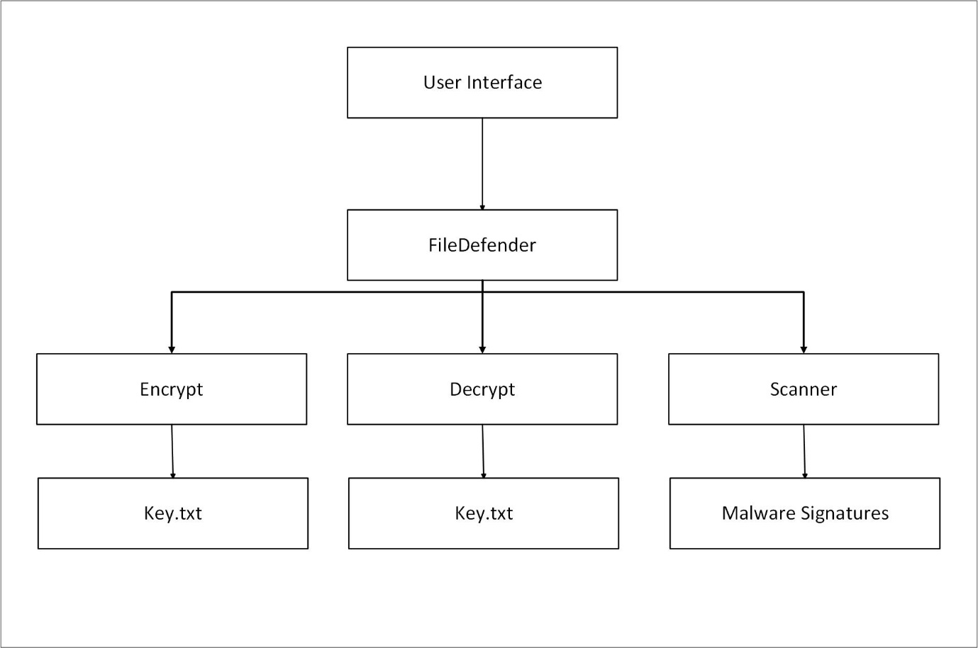
Figure 1. Functions Data Flow Diagram (DFD)

The above DFD shows the four modules of the File Defender program as separate processes. The GUI is connected to the File Defender module, which is the main module and is responsible for coordinating the different processes.
The Encrypt module is responsible for encrypting files in a directory(s) recursively and stores the encryption key in a text file (key.txt). The Decrypt module uses the encryption key to decrypt all the files.
The Scanner module is responsible for scanning all files and folders in a given directory recursively for files that have malware signatures. It matches each file with the malware signatures file in the "signatures" folder of the program.
The Key.txt file is used by the Encrypt and Decrypt modules to encrypt and decrypt files, respectively. The Malware Signatures file is used by the Scanner module to identify files with malware signatures.

Process Flowchart Diagram
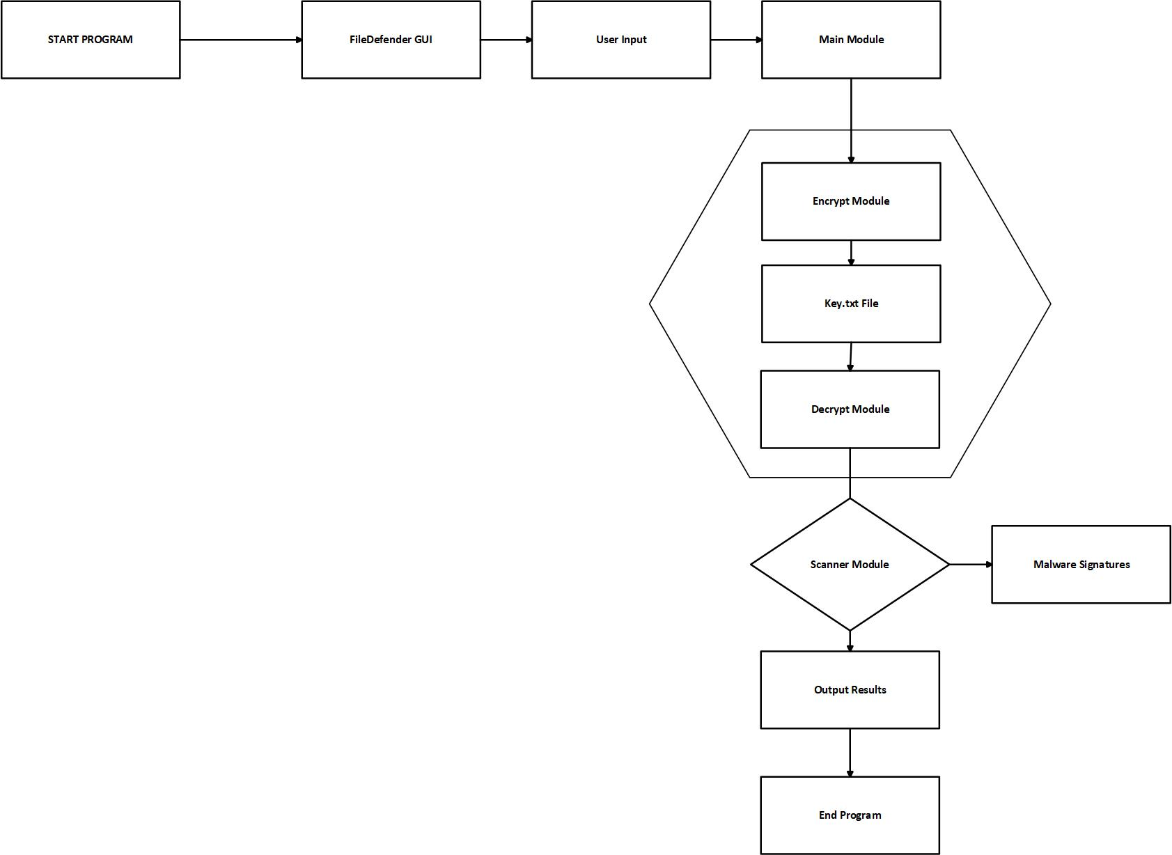
Figure 2. Process Flowchart Diagram

The above flowchart shows the flow of data and control in the File Defender program. The program starts when the user lunches it. The GUI is displayed, and the user interacts with the program by selecting the files or directory to encrypt, decrypt, or scan for malware signature. The main module is responsible for coordinating the different processes.

The Encrypt module encrypts the selected files or directory and stores the encryption key in a text file (key.txt). The Decrypt module uses the encryption key to decrypt the files. The Scanner module scans the selected files for malware signatures by comparing them with the malware signatures in the “signatures” folder.

The Key.txt file is used by the Encrypt and Decrypt modules to encrypt and decrypt files, respectively. The program outputs the results to the user. The program ends when the user exits it.

Chapter 6

SYSTEM DEVELOPMENT AND TESTING

Environment setup
Python was used as the programming language and Visual Studio Code as the integrated development environment (IDE) for the project. The project was created using the Windows OS. The following actions were made to provide an atmosphere that was appropriate for the project:

Python Installation
Python was installed on the computer after being obtained from the official website (https://www.python.org/).

Virtual Environment Setup
A virtual environment was built using the Python "venv" package to manage the project's dependencies. The virtual environment separates the project's requirements from those of the system's other Python projects.

Code Editor Installation
Visual Studio Code was installed on the system to edit and develop the Python code.

Packages Installation
The project was developed using a number of Python packages. The pip package manager was used to install these items. Install a package using <pip instll <package name>

Distribution and Testing
The program was finished, distributed, and put through its paces on four different Windows-based computers. Which have excellent results.

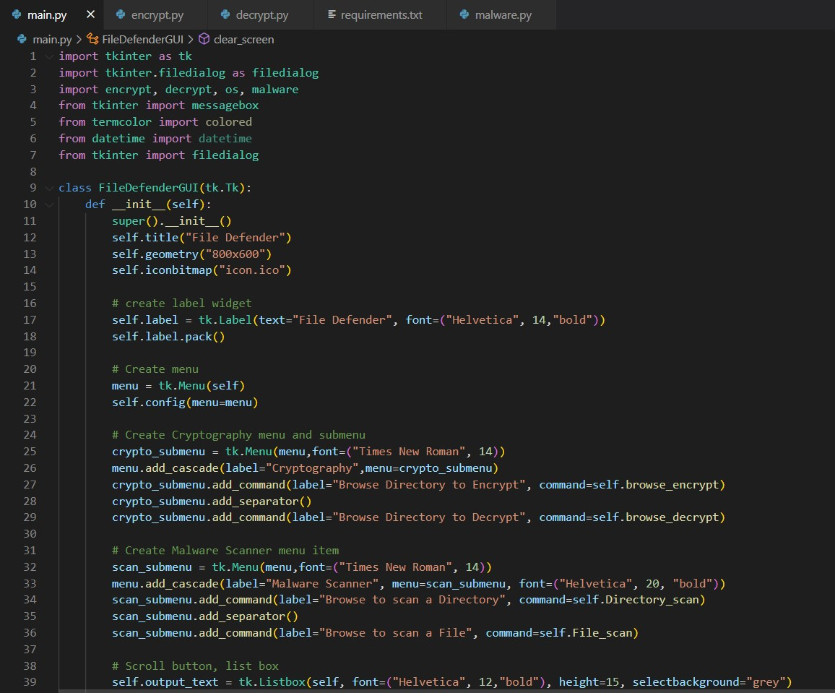
Figure 3. Main code
The main code creates a class called FileDefenderGUI that inherits from Tk and initializes the window with a title, size, and an icon. It creates a label widget and a menu bar with two menu items.
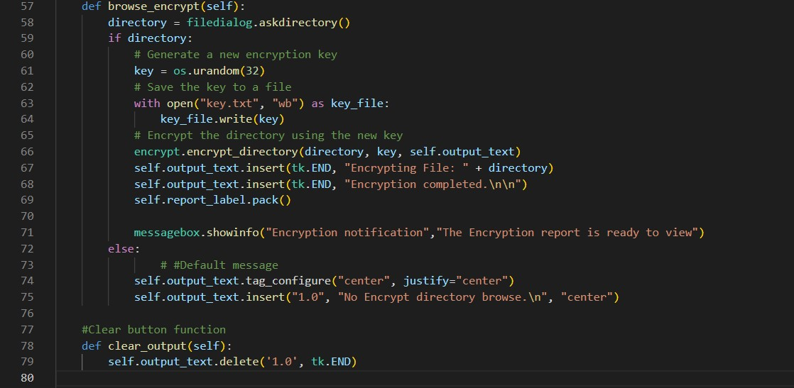
Figure 4. Encryption code
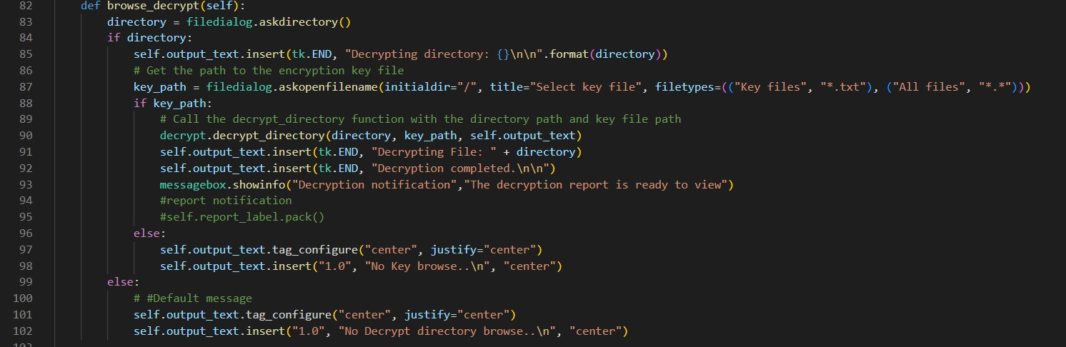
Figure 5. Decryption code
Cryptography code: The Cryptography menu has two submenu items that allow the user to browse a directory to either encrypt or decrypt files.
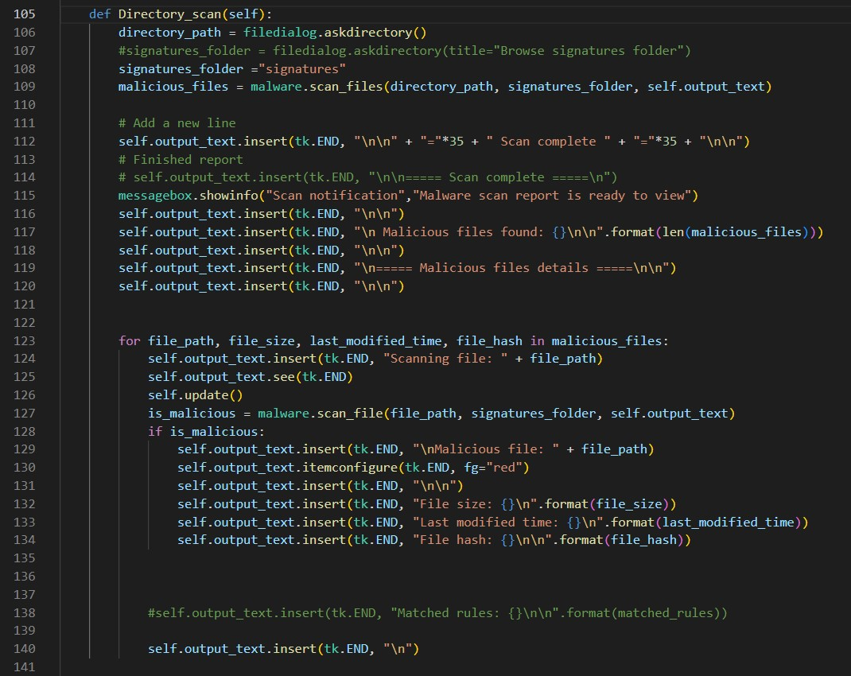
Figure 6. Malware scanning code
The Malware Scanner menu also has two submenu items that allow the user to browse a directory to scan for malware in either a file or directory. This program is a GUI application built with the Tkinter library in Python. It provides functionality to scan files in a directory for malicious code.
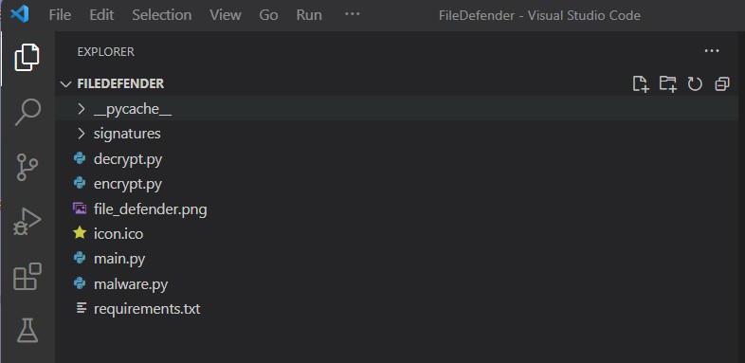
Figure 7. Files created
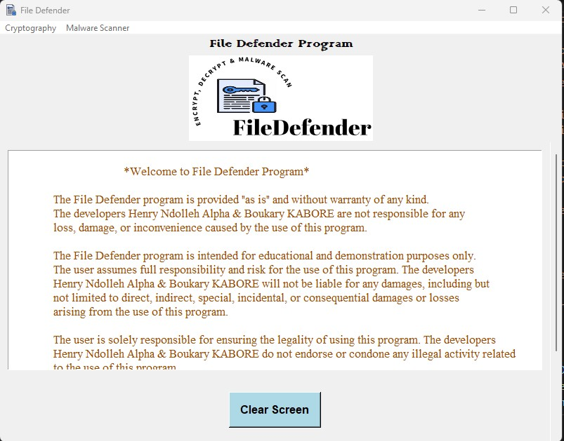
Figure 8. GUI of the program
The program also creates a scrollable text box with a clear screen button to clear all text in the window. The program generates a new encryption key and saves it to a file when the user selects a directory to encrypt. The key is used to encrypt the directory, and the output is displayed in the text box. When the decryption option is selected, the program prompts the user to select the directory to decrypt and the key file. The directory is decrypted using the key, and the output is displayed in the text box.
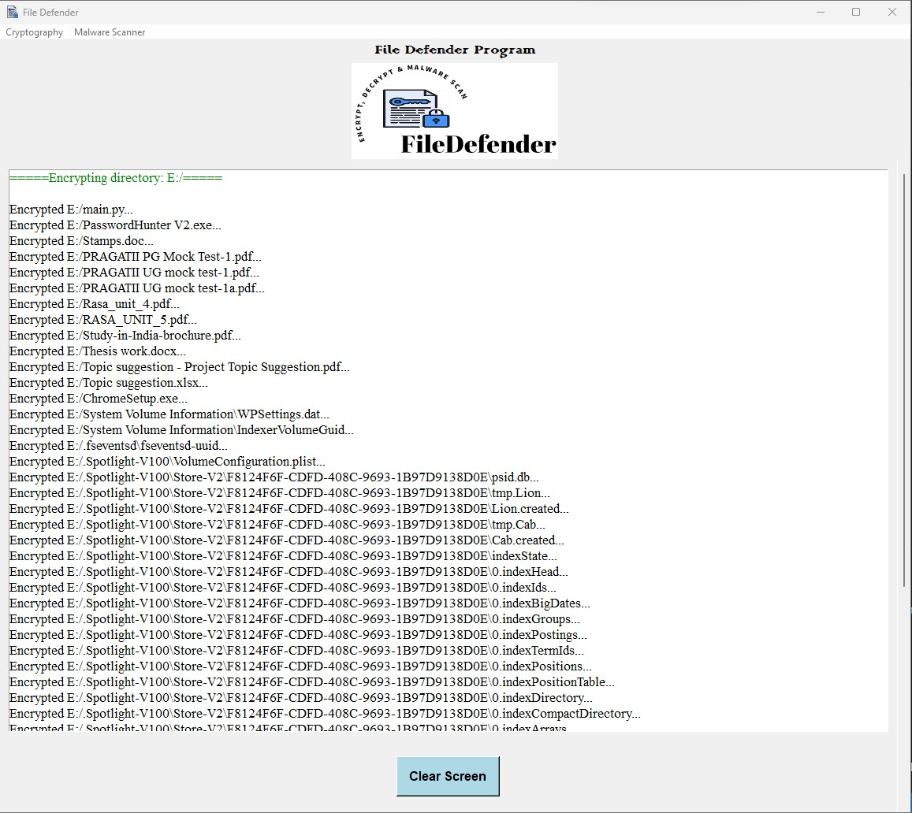
Figure 9. Result of the program encrypted directory
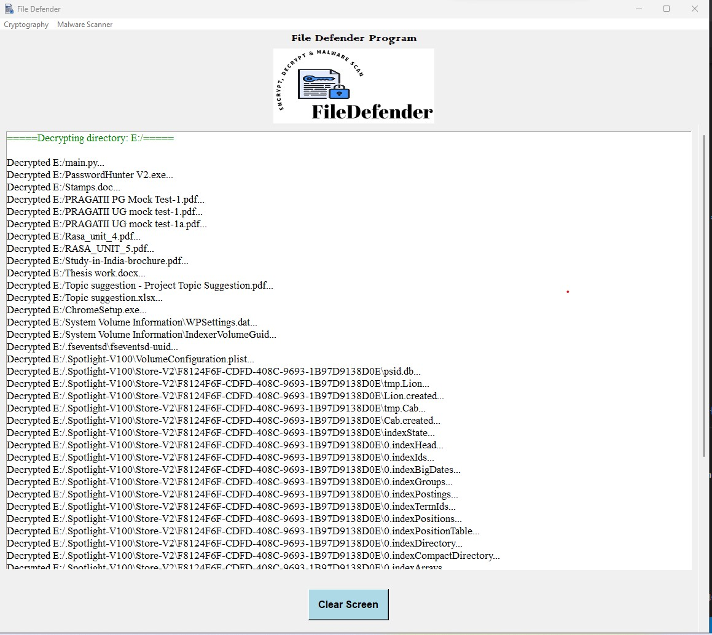
Figure 10. Result of the program decrypted directory

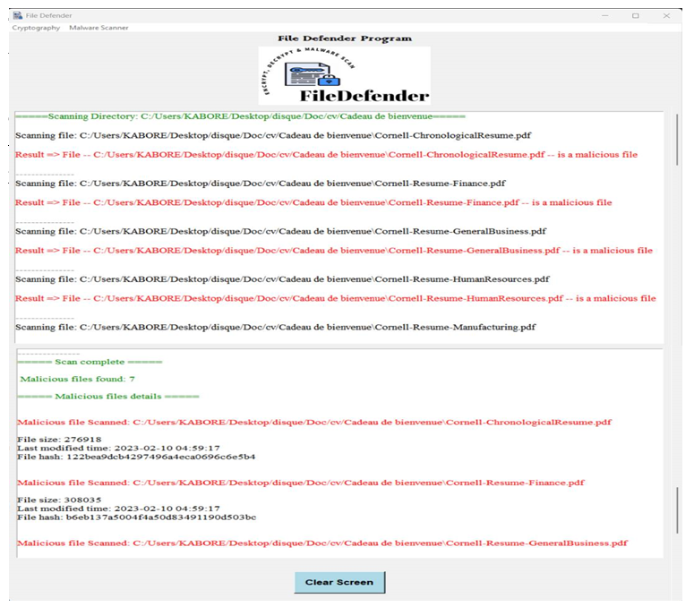
Figure 11. Result of the program malware scanning a directory

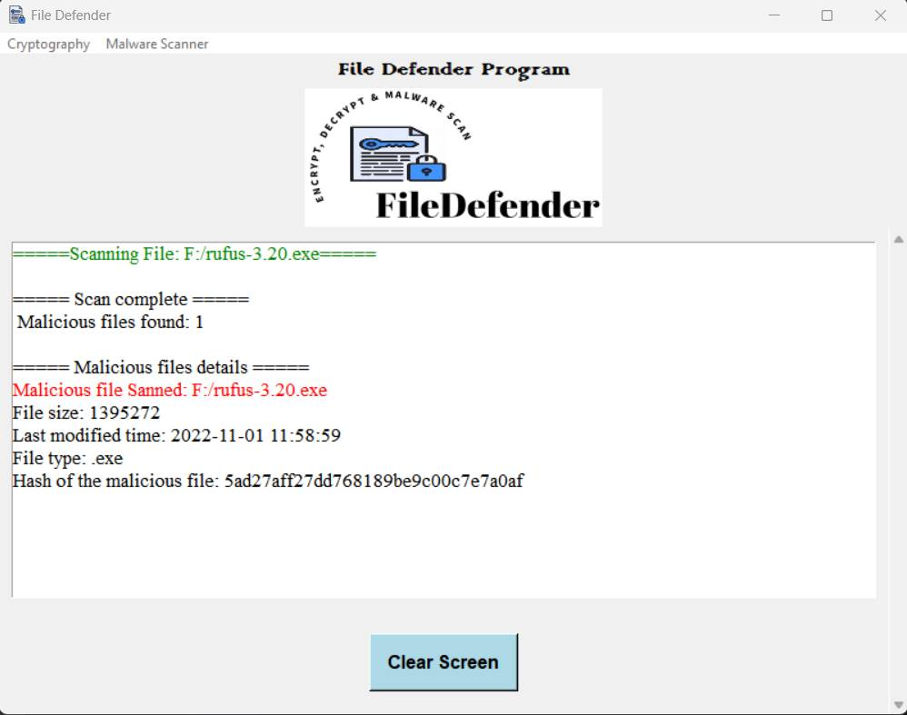
Figure 12. Single file with malware
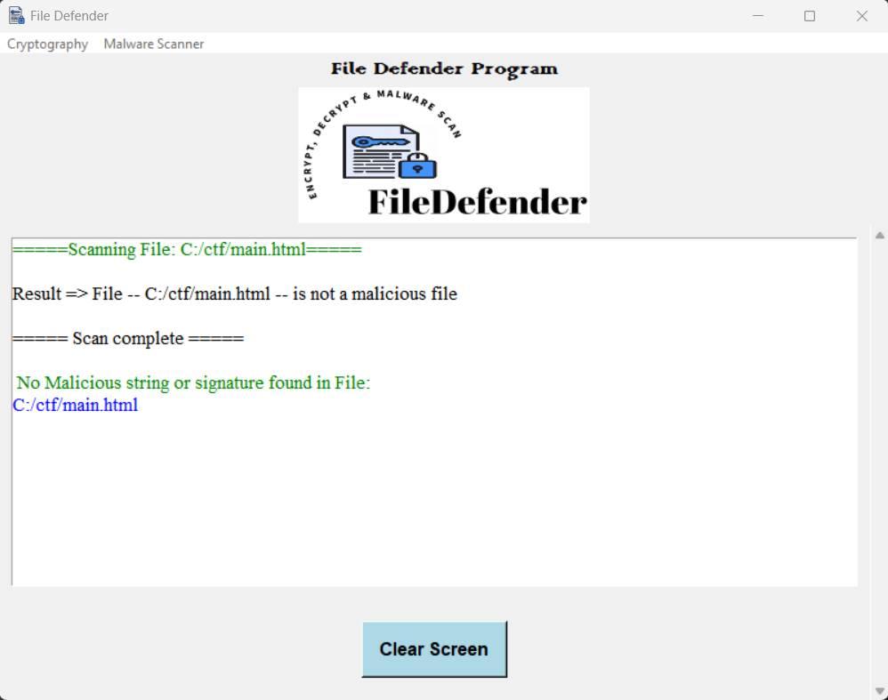
Figure 13. Single file with no malware

The program provides the option to scan a directory for malicious code. The user can browse a directory, and the program scans all files in the directory for signatures of known malicious code. The program outputs the results in the text box, showing the number of malicious files found. Finally, the program creates a message box to display a notification when encryption, decryption, or scanning is complete, indicating that the report is ready to view.

Conclusion
In conclusion, developing a program like File Defender that includes encryption, decryption, and malware scanning capabilities can be a challenging and rewarding experience. Through this project, we were able to gain a deeper understanding of cybersecurity concepts and programming languages such as Python, which are essential in the development of such programs.
One of the key takeaways from this project is the importance of prioritizing security measures in all aspects of software development. The increasing frequency of cyberattacks and data breaches highlights the need for robust cybersecurity solutions, and programs like File Defender can play a crucial role in securing sensitive data.
Another significant aspect of this project was the opportunity to learn how to integrate different functionalities within a single program. The use of external libraries and APIs allowed us to add more features to the program without starting from scratch, saving time and resources. This experience highlighted the importance of efficient and effective use of resources in software development, which can lead to better results and user satisfaction.
Overall, the development of File Defender was an excellent opportunity to apply theoretical concepts and programming skills in a practical context. The project provided valuable insights into the complexity of cybersecurity and software development and highlighted the importance of continuous learning in the ever-evolving field of technology. We hope that this project can serve as a starting point for those interested in developing similar programs and contribute to the advancement of cybersecurity solutions.

LEARNING DURING PROJECT WORK
Learning during project work is an essential part of the process. It involves gaining new knowledge and skills as you work on a project. This learning can come from various sources, such as researching online, seeking guidance from mentors or colleagues, attending training or workshops, and experimenting with new techniques.
The process of learning during project work can be very beneficial, as it allows you to apply new knowledge and skills directly to the project at hand. This can help you to solve problems more efficiently and effectively, and to develop a deeper understanding of the project requirements and goals.
In addition, learning during project work can also help you to build your expertise and develop new competencies. This can make you a more valuable asset to your team or organization, and can open up new career opportunities.
To make the most of learning during project work, it is important to be proactive and seek out new opportunities for learning. This may involve identifying areas where you need to improve your skills or knowledge, seeking feedback and guidance from colleagues or mentors, and experimenting with new approaches and techniques.
Overall, learning during project work is a key component of professional development, and can help you to build your skills, knowledge, and expertise over time.

Future Improvements
To improve your learning during project work in the future, you could try:
- Reflecting on what you learned: After completing a project, take some time to reflect on what you learned and what you could have done differently. This will help you identify areas where you need to improve and develop strategies for future projects.
- Seeking feedback: Ask for feedback from your peers, mentors, or instructors. This can help you identify areas where you need to improve and learn from your mistakes.
- Collaborating with others: Collaborating with others can help you learn new skills and perspectives. Working in a team can also help you share the workload and learn from each other's strengths.
- Staying organized: Organize your work by breaking it down into smaller tasks, setting deadlines, and keeping a schedule. This will help you manage your time and ensure that you complete your project on time.
- Learning from resources: Use online resources, such as tutorials, videos, and articles, to learn new skills and concepts. This can help you broaden your knowledge and enhance your project work.
- Trying new things: Experiment with new tools, techniques, or approaches to expand your skill set and improve your work. Don't be afraid to take risks and try new things.
- Applying what you learn: Try to apply what you learn in your projects. This will help you solidify your understanding and develop new skills

Bibliography

Online Resource
Here are some online resources that may be useful for learning more about encryption, decryption, and malware scanning in the context of file defender programs:
- Encryption and Decryption:
- "A Beginner's Guide to Encryption: What It Is and How to Set It Up" (Lifehacker) - https://lifehacker.com/a-beginners-guide-to-encryption-what-it-is-and-how-to-1691429102
- "How Encryption Works, and Why It's So Important" (Wired) - https://www.wired.com/story/encryption-what-is-it-guide/
- "How to Encrypt and Decrypt Files on Any Device" (MakeUseOf) - https://www.makeuseof.com/encrypt-decrypt-files/
- Malware Scanning:
- "10 Best Online Malware and Virus Scanners to Scan Files & Websites" (Techrrival) - https://www.techrrival.com/online-malware-virus-scanners/
- "The Best Malware Removal and Protection Software for 2021" (PCMag) - https://www.pcmag.com/picks/the-best-malware-removal-and-protection-tools
- Programming:
- "Python 3.9.9 documentation" - https://docs.python.org/3/
- "Learn Python the Hard Way" (book by Zed A. Shaw) - https://learncodethehardway.org/python/
- "Codecademy" (online coding tutorials) - https://www.codecademy.com/
- "Tkinter GUI Programming by Example" by David Love - https://www.packtpub.com/product/tkinter-gui-programming-by-example/9781788627481
- "Python and Tkinter Programming" by John E. Grayson - https://www.python-course.eu/tkinter.php
- "Python GUI Programming With Tkinter" by Jan Bodnar - https://pythonspot.com/tkinter/
- "Python GUI Programming Cookbook" by Burkhard A. Meier - https://www.packtpub.com/product/python-gui-programming-cookbook-second-edition/9781801076943
- "Python and Django Full Stack Web Developer Bootcamp" by Jose Portilla - https://www.udemy.com/course/python-and-django-full-stack-web-developer-bootcamp

